EXERCISE – 05 (RIDGE REGRESSION)
1. AIM
To implement Ridge Regression (L2 regularization) on the housing dataset using fourth-degree polynomial features and to show how it reduces the overfitting of an ordinary linear regression model.
2. ALGORITHM
1. Load the housing dataset and convert the categorical columns into dummy variables.
2. Separate the predictors from the target variable price and split the data in an 80:20 ratio with random_state = 42.
3. Standardize the features using StandardScaler.
4. Expand the 13 scaled features into 2379 polynomial features of degree 4.
5. Train an ordinary Linear Regression model and record its training and testing R² scores.
6. Train a Ridge Regression model with alpha = 100 and record its training and testing R² scores.
7. Compare the two models in a table and a bar chart, and calculate the gap between training and testing R².
3. PROGRAM
import pandas as pd
import numpy as np
import matplotlib.pyplot as plt
from sklearn.model_selection import train_test_split
from sklearn.preprocessing import StandardScaler, PolynomialFeatures
from sklearn.linear_model import LinearRegression, Ridge
from sklearn.metrics import r2_score
df = pd.read_csv("Housing.csv")
df.head()
df = pd.get_dummies(df, drop_first=True)
df.head()
X = df.drop("price", axis=1)
y = df["price"]
X_train,X_test,y_train,y_test = train_test_split(
X,
y,
test_size=0.2,
random_state=42
)
scaler = StandardScaler()
X_train_scaled = scaler.fit_transform(X_train)
X_test_scaled = scaler.transform(X_test)
poly = PolynomialFeatures(
degree=4,
include_bias=False
)
X_train_poly = poly.fit_transform(X_train_scaled)
X_test_poly = poly.transform(X_test_scaled)
print("Original Features :", X_train.shape[1])
print("Polynomial Features :", X_train_poly.shape[1])
linear = LinearRegression()
linear.fit(X_train_poly, y_train)
train_pred = linear.predict(X_train_poly)
test_pred = linear.predict(X_test_poly)
train_r2 = r2_score(y_train, train_pred)
test_r2 = r2_score(y_test, test_pred)
print("LINEAR REGRESSION")
print("Training R2 :", round(train_r2,4))
print("Testing R2 :", round(test_r2,4))
ridge = Ridge(alpha=100)
ridge.fit(X_train_poly, y_train)
train_pred = ridge.predict(X_train_poly)
test_pred = ridge.predict(X_test_poly)
ridge_train = r2_score(y_train, train_pred)
ridge_test = r2_score(y_test, test_pred)
print("RIDGE")
print("Training R2 :", round(ridge_train,4))
print("Testing R2 :", round(ridge_test,4))
comparison = pd.DataFrame({
"Model":[
"Linear Regression",
"Ridge"
],
"Train R2":[
train_r2,
ridge_train
],
"Test R2":[
test_r2,
ridge_test
]
})
print(comparison)
comparison.plot(
x="Model",
y=["Train R2", "Test R2"],
kind="bar",
figsize=(10,6)
)
plt.title("Reducing Overfitting using Ridge Regularization")
plt.ylabel("R² Score")
plt.xticks(rotation=10)
plt.grid(axis="y")
plt.show()
comparison["Difference"] = comparison["Train R2"] - comparison["Test R2"]
print(comparison)

4. OUTPUT
The program was executed on the Housing dataset (Housing.csv) and produced the following output:
price area bedrooms ... parking prefarea furnishingstatus
0 13300000 7420 4 ... 2 yes furnished
1 12250000 8960 4 ... 3 no furnished
2 12250000 9960 3 ... 2 yes semi-furnished
3 12215000 7500 4 ... 3 yes furnished
4 11410000 7420 4 ... 2 no furnished
[5 rows x 13 columns]
price ... furnishingstatus_unfurnished
0 13300000 ... False
1 12250000 ... False
2 12250000 ... False
3 12215000 ... False
4 11410000 ... False
[5 rows x 14 columns]
Original Features : 13
Polynomial Features : 2379
LINEAR REGRESSION
Training R2 : 0.994
Testing R2 : -2874.767
RIDGE
Training R2 : 0.9637
Testing R2 : 0.2892
Model Train R2 Test R2
0 Linear Regression 0.994023 -2874.766987
1 Ridge 0.963736 0.289156
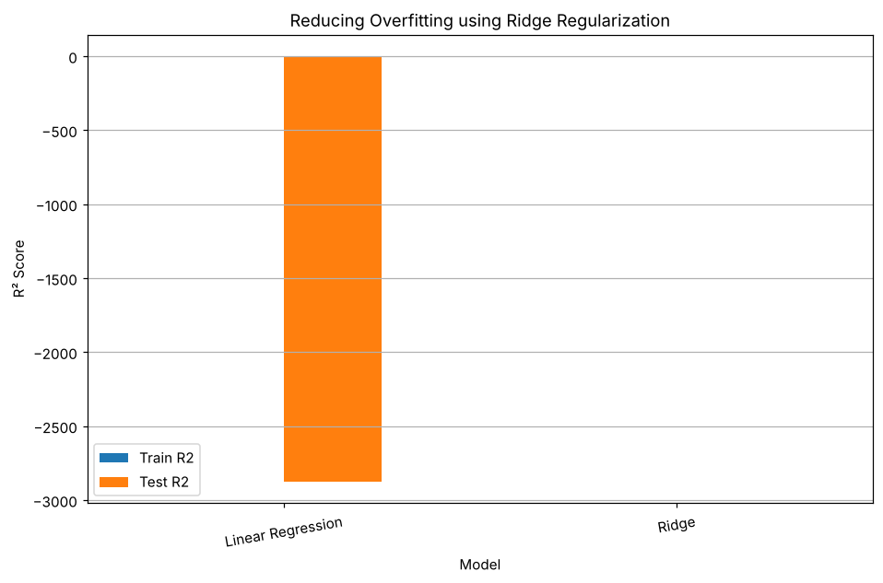
Model Train R2 Test R2 Difference
0 Linear Regression 0.994023 -2874.766987 2875.76101
1 Ridge 0.963736 0.289156 0.67458

5. RESULT
Thus, the Ridge Regression practical was implemented successfully. The ordinary linear model overfitted badly, with a training R² of 0.9940 and a testing R² of −2874.77. Ridge Regression (alpha = 100) reduced the training R² to 0.9637 and improved the testing R² to 0.2892, shrinking the gap between training and testing scores from 2875.76 to 0.67.

